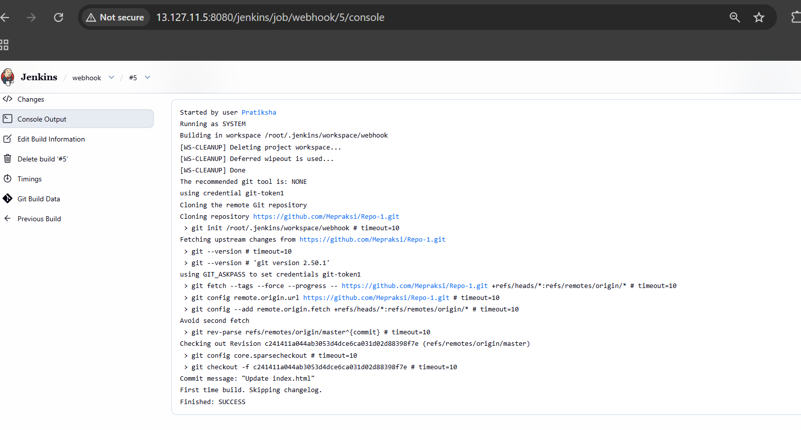
Job-1 for Repo-1-webhook
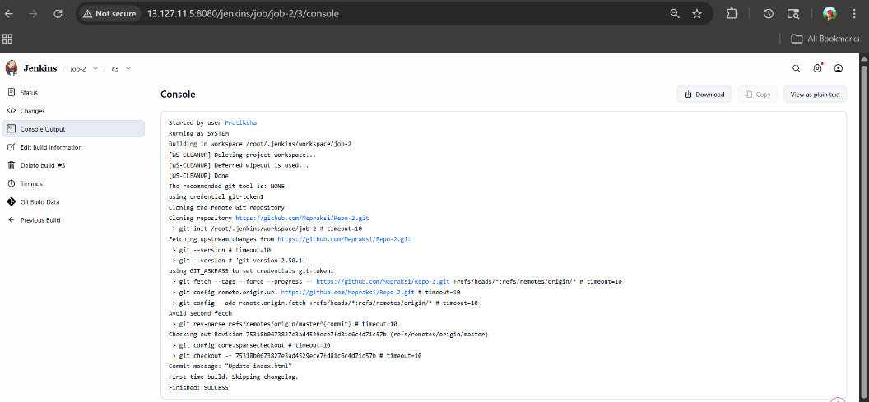
Job-2 for Repo-2-2026Q1
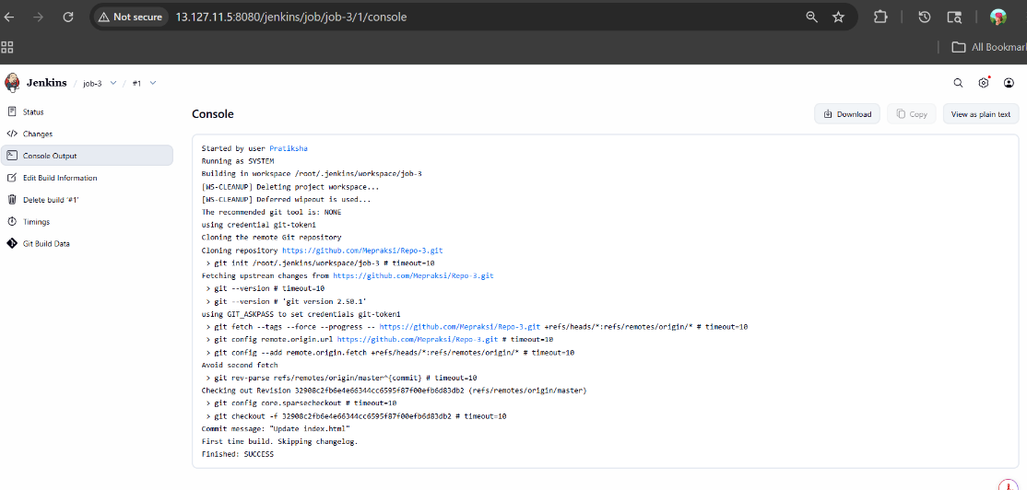
Job-3 for Repo-3 2026Q1.1

